ASSIGNMENT: ALGORITHM DESIGN

QUESTION 12
EMPLOYEE ATTENDANCE SYSTEM
GROUP MEMBERS | 1.LUQMAN NUR HAKIM HAMIDUN BIN ABDULLAH | A26DW0701
GROUP MEMBERS | 2. MUHAMMAD THAHA BIN ABDUL MANAP | A26DW2262
GROUP MEMBERS | 3.NUR ARISSA MIRZA BINTI ABDUL RAHMAN | A26DW2419
GROUP MEMBERS | 4. NURIN AYRA BINTI AHMAD | A26DW2219
GROUP MEMBERS | 5. ZARRA QYRANA BINTI SHAFIRULL | A26DW0601

- Problem Analysis

The Employee Attendance System is designed to calculate an employee’s actual working hours, overtime hours, and attendance status based on the scheduled start time, clock-in time, clock-out time, break duration, and standard working hours.

The system first calculates the total duration between the clock-in and clock-out times. The break duration is then deducted to determine the actual working hours. The actual working hours are compared with the standard working hours to determine the overtime hours. The system also compares the clock-in time with the scheduled start time to determine whether the employee is late or on time.

Objectives
- Calculate the employee’s actual working hours.
- Deduct the break duration from the total time worked.
- Calculate the employee’s overtime hours.
- Identify whether the employee arrived late.
- Display working hours, overtime hours, and attendance status.

Assumptions
- Time values are entered in 24-hour format.
- The clock-out time must be later than the clock-in time.
- Break duration is entered in hours.
- Standard working hours are entered in hours.
- Overtime occurs when actual working hours are greater than standard working hours.
- If actual working hours are equal to or less than standard working hours, overtime is 0 hours.
- An employee is considered Late when the clock-in time is later than the scheduled start time.
- An employee is considered On Time when the clock-in time is equal to or earlier than the scheduled start time.
- An employee is considered On Time when the clock-in time is equal to or earlier than the scheduled start time.
- An employee is considered On Time when the clock-in time is equal to or earlier than the scheduled start time.
- The system calculates attendance for one working day.

Constraints
- Time values must be valid.
- Clock – out time cant be earlier than clock – in time.
- Break duration cannot be negative.
- Standard working hours cannot be negative.
- Break duration should not exceed the total duration between clock-in and clock-out.
- This basic version does not calculate overnight shifts.

- IPO
Input | - scheduledStartTime  - clockInTime  - clockOutTime  - breakDuration  - standardWorkingHours
Process | - Calculate initial working hours:  workingHours = clockOutTime – clockInTime  - Deduct break duration:  workingHours = workingHours – breakDuration  - Determine overtime hours:  IF workingHours > standardWorkingHours  THEN overtimeHours = workingHours - standardWorkingHours  ELSE overtimeHours = 0  - Determine attendance punctuality status:  IF clockInTime > scheduledStartTime  THEN attendanceStatus = "Late"  ELSE attendanceStatus = "On Time"
Output | - workingHours  - overtimeHours  - attendanceStatus

- Pseudocode

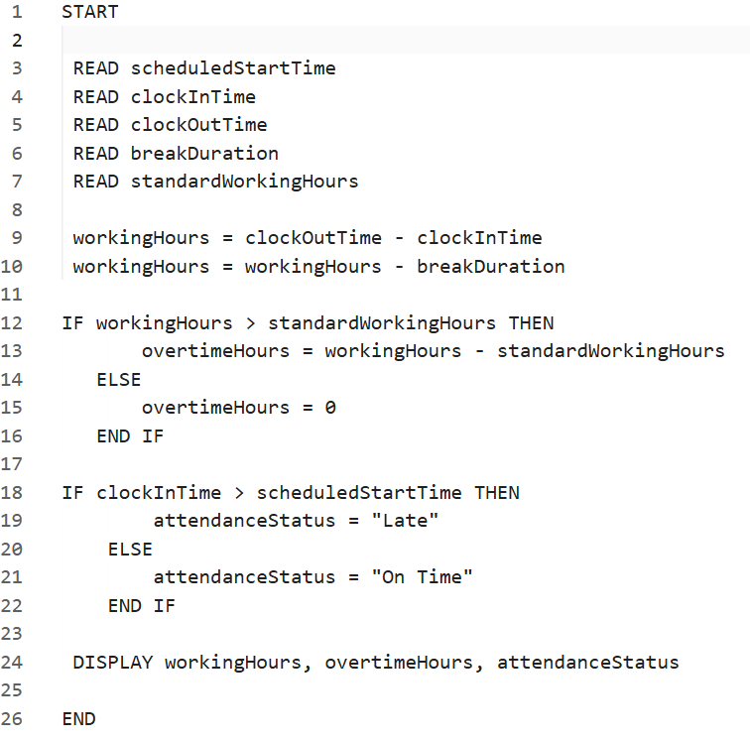

- Flowchart
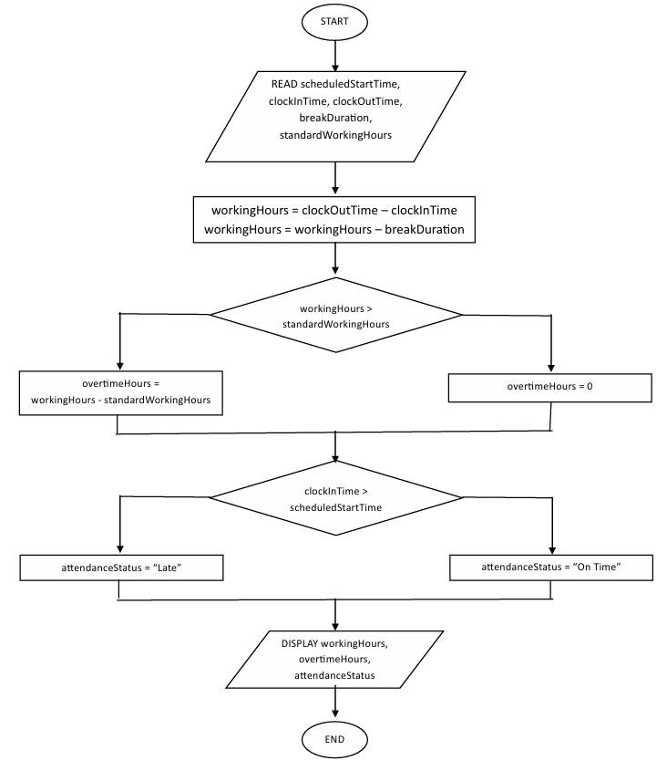

- Explain The Algorithm
The algorithm is designed using a sequence of calculations and decision-making conditions. First, the system receives five inputs:
- scheduled start time
- clock-in time
- clock-out time
- break durations
- standard working hours

The system then calculates the total duration between the clock-in and clock-out times. The break duration is deducted from this duration to obtain the employee's actual working hours.
Next the algorithm compares the actual working hours with the standard working hours. If the actual working hours are greater than the standard working hours, the difference is considered overtime. Otherwise, the overtime is set to zero.
The algorithm also compares the clock-in time with the scheduled start time. If the employee clocks in after the scheduled start time, the attendance status is set to 'Late'. Otherwise, the status is set to 'On Time'.
Finally, the system displays three outputs:
1) Working Hours
2) Overtime Hours
3) Attendance Status

- Test Cases

TEST CASE 1:
On time with overtime hours
===== EMPLOYEE ATTENDANCE SYSTEM =====
Enter Scheduled Start Time (Hour minute): 8 00
Enter Scheduled End Time (Hour minute): 18 00
Enter Clock-in Time (Hour minute): 8 00
Enter Clock-out Time (Hour minute): 20 00
Enter break duration (Hours): 2
Enter standard working hours: 8
===== ATTENDANCE RESULT =====
Working Hours: 4 hours 0 minute
Overtime Hours: 2 hours 0 minutes
Attendance Status: On time

TEST CASE 2:
Late with overtime hours
===== EMPLOYEE ATTENDANCE SYSTEM =====
Enter Scheduled Start Time (Hour minute): 8 00
Enter Scheduled End Time (Hour minute): 18 00
Enter Clock-in Time (Hour minute): 8 30
Enter Clock-out Time (Hour minute): 20 30
Enter break duration (Hours): 2
Enter standard working hours: 8
===== ATTENDANCE RESULT =====
Working Hours: 4 hours 0 minute
Overtime Hours: 2 hours 0 minutes
Attendance Status: Late

TEST CASE 3:
Invalid clock – out time
===== EMPLOYEE ATTENDANCE SYSTEM =====
Enter Scheduled Start Time (Hour minute): 8 00
Enter Scheduled End Time (Hour minute): 18 00
Enter Clock-in Time (Hour minute): 8 00
Enter Clock-out Time (Hour minute):7 00
ERROR! Clock-out time cant be earlier than clock-in time

